FIB (FRAMEWORK BANK OF IDEA)
The next project between the supervisor and the "member" candidate below is in full compliance with the WYCM organization's confidentiality ordinances. You agree in accordance with the laws and regulations of WYCM in accordance with the guidelines set out in your responsible work manual, including participation, product development and/or anything related to other project units, even caring for your colleagues, and in particular all left behind after a meeting or project. Documents or copies must be spoken as directed or returned to the supervisor.
* the mark means a very important procedure, so you have to work hard in that area.
Date initiated; May 20, 2021
1. The Backbone of Research Paper
[MAKE CONCISE AND CLEAR (1 PARAGRAPH OR LESS)] i.e. If you want to explain the topic of swimming here, you need to simply grab a skeleton. Let's think about it easily, and from now on, let's think of an artist who made a sculpture. You are that artist. To make a beautiful sculptural shape, start with the backbone. The following table belongs to that backbone.

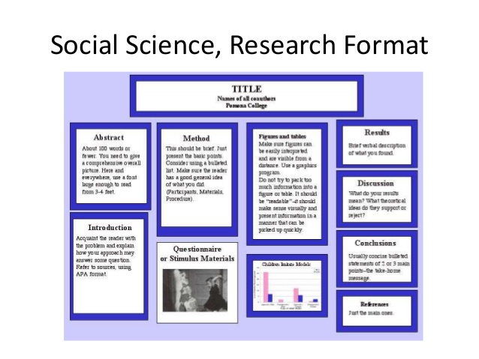

Item |  | This is the analysis of natural Science Research Paper of Biology | Objectives / Comments
A  Abstract |  | {Introduction}  {The purpose of this study}  {findings}  {conclusion / *verification of the previous purpose of study or hypothesis}
I  Introduction | Intro  Literature  Purpose of this study  Hypothesis | {Introduction}  {Background/ Literature review in history}  {*Thesis Statement~ The direction of this study}  {If possible, describe your hypothesis} | This paragraph specifically states the purpose of the study. If can, it shall also states the hypothesis the author developed based on background reading and observations.
 | Resource
M  Method | The origin  The fact  Example | { (transitional phase)The Origin of Social Issue}  {Facts of issues}  {Example to be supported} | The methods begin by indicating where the research organisms were obtained.  Specific examples about the organisms are included, e.g. number of organisms, sexes, ages, and morphology, and demography  How organisms were housed, including specific dimensions of race, etc. and the unexpected conditions of history and immigration, is also included.  The types of test materials used are described in detail, as are the methods.  Description of methods includes assumptions made and type of analysis to be performed on the data.
 | Resource | { Be recommended of the table and the Fig}
R  Results | Data/ Facts | { Data }  . | The author interprets the data for the reader in text form. The author does not expect the reader to interpret the results from a table of data, but instead provides his/her interpretation for the reader
 | Fig  Table | { Be recommended of the table and the Fig}
 | Resource
D  Discussion | Discussion ( findings)  Conclusion  Further studies | { Findings }  { Conclusion / *Verification of previous purpose of study (Hypothesis) } | The discussion provides an explanation of what the results mean relative to the original purpose and/or hypothesis stated in the introduction
 | Reference
R
Reference
A  Appendices |  | {If applicable, write it down here}

